Web Designing Assignment

HTML

# Are the HTML tags and elements the same thing?

**Ans :-** HTML tags and elements are different things. An html tags is an indication to a web browser of how web page should displayed. But an html element is an individual component of HTML.

# What are tags and attributes in HTML?

**Ans :-** HTML tags are used to create HTML documents. Attributes provide additional information about elements. Attributes are always specified in the start tag.

# What are the void element in HTML? With Example.

**Ans :-** A void element is an element whose content model never allows

it to have contents under any circumstances like hr, br, input, etc…

**Example :-** [**<br>**](https://developer.mozilla.org/en-US/docs/Web/HTML/Element/br)[<hr>](https://developer.mozilla.org/en-US/docs/Web/HTML/Element/hr) [<img>](https://developer.mozilla.org/en-US/docs/Web/HTML/Element/img) [<link>](https://developer.mozilla.org/en-US/docs/Web/HTML/Element/link) [<meta>](https://developer.mozilla.org/en-US/docs/Web/HTML/Element/meta)

# What are HTML Entities ? With example.

**Ans:-** the HTML entities used to display < and > respectively. Hence to display <p> we need to use &lt; and &gt;



**Example:**

# What are different types of lists in HTML? With Example.

**Ans:-** There are Three types of lists in HTML, likely unordered lists, ordered lists, and definition lists.

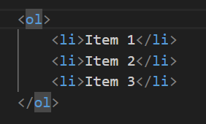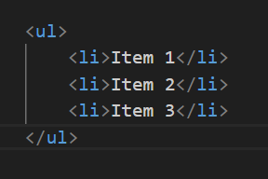**Example** :- **Unorder list :- Order List :-**

**Definition list** :-

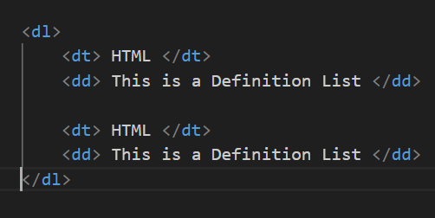

# What is the ‘class’ attribute in HTML? With Example.

**Ans :-** The class attribute specifies one or more classnames for an element. The class attribute is mostly used to point to a class in a style sheet.



**Example :-**

# What is the difference between the ‘id’ attribute and the ‘class’

**attribute of HTML elements? With Example.**

**Ans :-** A Class name can be used by multiple time HTML elements, And an ID name must only be used by one HTML element.

**Example :-**

# What are the various formatting tags in HTML ?

**Ans :-** The formatting can be used to set the text styles, like Bold Tag, Italic

Tag, Underline Tag, Strong Tag, Subscript Tag, Superscript Tag, etc…

# How is Cell Padding different from Cell Spacing? With Example.

**Ans :-** Cellpadding basically defines the space present between a table cell's border and the content present in it. Cellspacing basically defines the space present between individual adjacent cells.

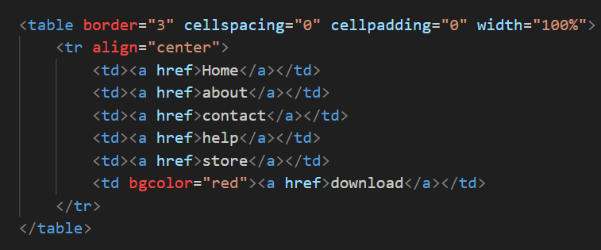**Example :-**

# How can we club two or more rows or columns into a single row or column in an HTML table?

**Ans :-** You can merge two or more table cells in a column using the colspan attribute in a HTML tag (table data). To merge two or more row cells, use the rowspan attribute.

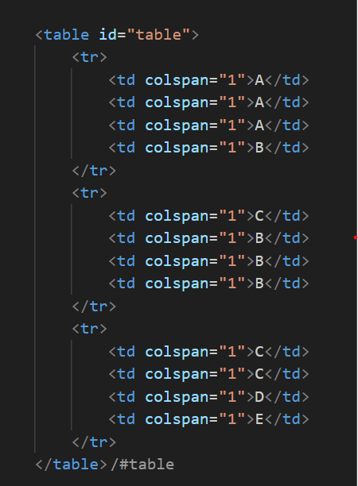 **Example:**

# What is the difference between a block-level element and an inline element?

**Ans :-** Block elements always start from a new line. Inline elements never start from a new line. Block elements cover space from left to right as far as it can go. Inline elements only cover the space as bounded by the tags in the HTML element.

# How to create a Hyperlink in HTML?

**Ans :-** Used Tag and create Hyperlink in HTML.

**Example** :-

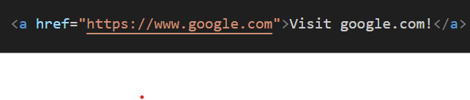

# What is the use of an iframe tag? With example.

**Ans:-** An inline frame (iframe) is a HTML element that loads another HTML page within the document.

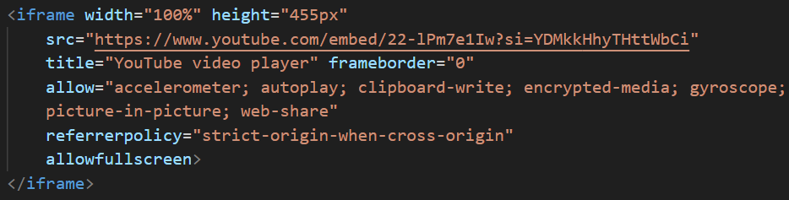**Example:**

# What is the use of a span tag? Explain with example?

**Ans :-** The tag is an inline container used to mark up a part of a text, or a part of a document. The tag is easily styled by CSS .

# Example : -

# 

# How to insert a picture into a background image of a web page? with example.

**Ans :-** Add background image is using the image tag inside the <body> tag.

**Example:**

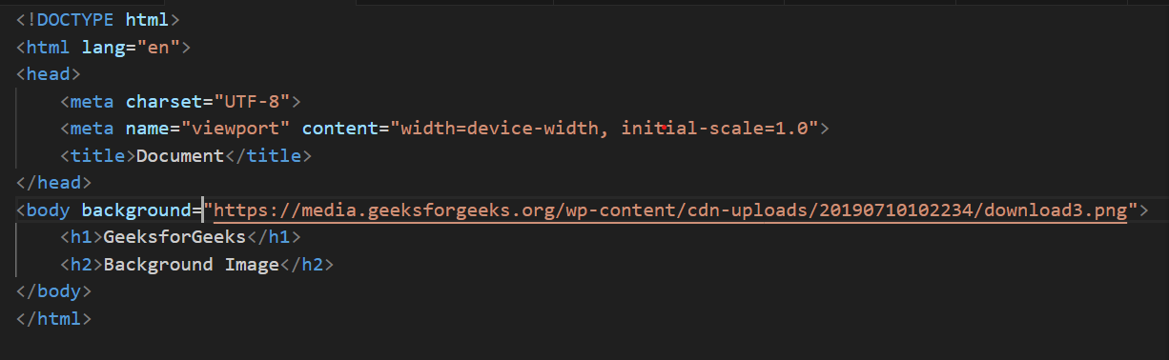

# How are active links different from normal links?

**Ans :-** An active link are underline and blue or red. And normal link are only for underline not show any other color in link.

# What are the different tags to separate sections of text?

**Ans :-** The <br> and <hr> tag is one way to separate the lines of text.

# What is SVG?

**Ans :-** Scalable Vector Graphics (SVG) is a web-friendly vector file format. As opposed to pixel-based raster files like JPEGs, vector files store images via mathematical formulas based on points and lines on a grid.

1. **What is difference between HTML and XHTML?**

**Ans :-**

**HTML :-** Hypertext Markup Language is a markup language used to create web pages and other information that can be displayed in a web browser.

**XHTML :-** eXtensible Hypertext Markup Language is a markup language that is a stricter version of HTML and conforms to XML syntax.

1. **What are logical and physical tags in HTML?**

**Ans :-**

Physical tag: These tags are used to provide the visual appearance to the text. Example :- <b>, <i>,

Logical tag: These tags are used to add some logical or semantic value to the text. Example : - <strong>